**Project Wireless and Mobile Computing**

**GotRex Application**

**by**

**Naensinee Soongsiri 5888165**

**Amonnat Tengputtipong 5888202**

**Intukorn Limpachaveng 5888261**

**ITCS424 – Wireless and Mobile Computing**

**Faculty of Information and Communication Technology**

**Mahidol University**

**2018**

**Overview of the project**

GotRex is a petting game for taking care the baby Got-Rex (Godzilla or Tyrannosaurus Rex). The users have to put their love and caring to their Got-Rex. Feed him/her and get him/her to bed. They can capture their T-rex moments and collect them in the users’ album or camera roll. Their baby Got-Rex can evolve into Tyrannosaurus Rex or Godzilla, which depends on how they take care on the Baby Got-Rex.

**The objective of the project**

GotRex application aims to be a learning application for a player to be responsible, happy and more observant.

First, the application will develop the player’s responsibility. There are two results after a player finish taking care of his or her pet. The first adult result on this application is the Tyrannosaurus, which means that the player have been taking good care on the baby. On the other hand, if the player is fail to take responsibility on baby, the result will be the Godzilla. Thus, these two results will teach the player to know that each characteristic result can be affected by how they treated on their baby.

Second, this application will use the advantage of the game play, in order to make a player feel relief from stress. This application will be suitable to be a time killer because a player can enjoy in doing various things with the virtual pet. Moreover, it can be another alternative choice for user who want to have a pet. As the research supported by U.S. Food and Drug Administration claimed that people who have a pet are quickly recover from stress than people who not have a pet.

Last, GotRex application can build up the observant characteristic of a player. As they have to observe how well of the baby so that they can take care of it without having the notification

**Tyrannosaurus Baby Got-Rex Godzilla**

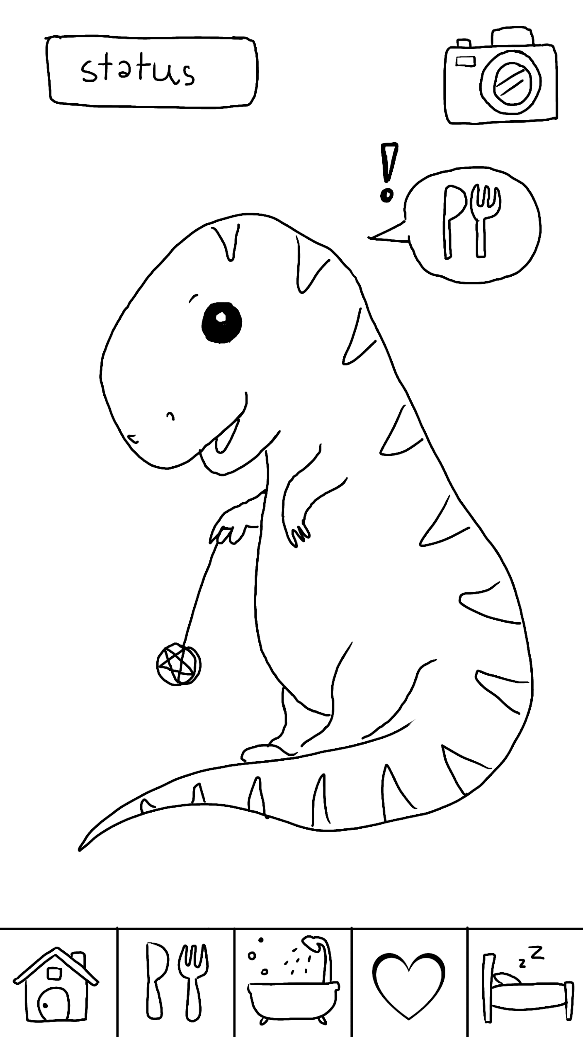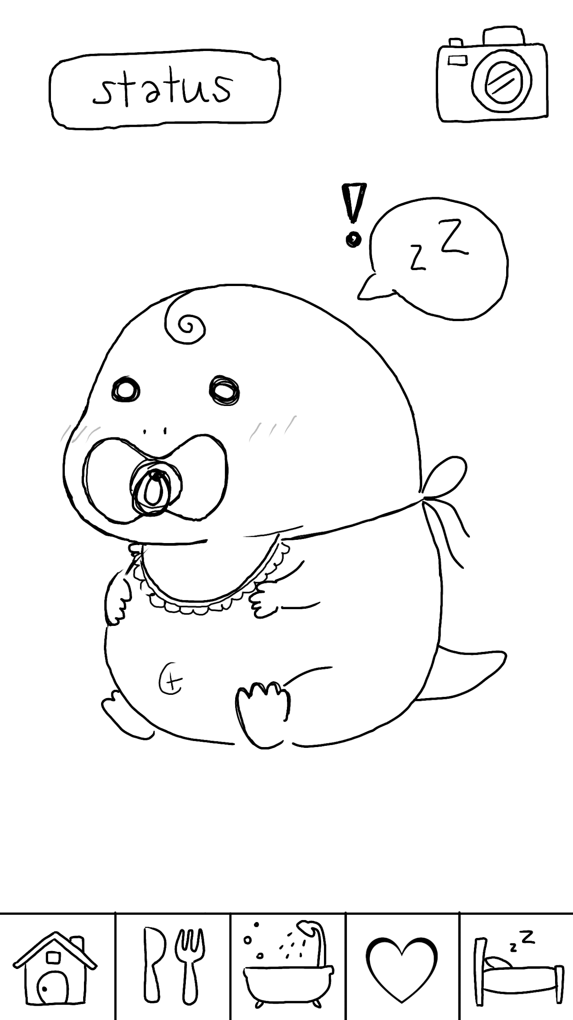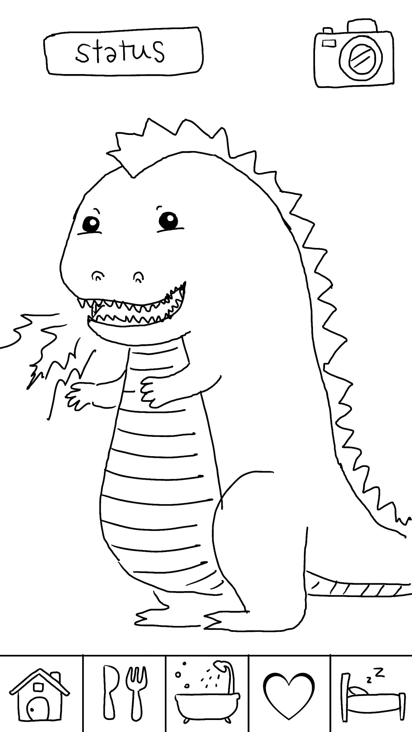

**Included Features:**

* **Tabs** - bottom navigation
* **Animated images** - the baby, T-rex, and Godzilla
* **Preferences** - record the time of player’s last access
* **Dialogs**
* **Capture Screen**
* **Drag and Drop**

**Included Pages:**

* **Main Activity** – provides bottom navigation
* **GotRexAdult Activity** – show the baby when growing up and let the player plays a gameagain
* **Home Fragment**
* **Eat Fragment**
* **Bath Fragment**
* **Status Fragment**
* **Sleep Fragment**

**Database columns:**

* **ID**
* **Name**
* **Hungry**
* **Clean**
* **Happy**
* **Energy**
* **Bond**
* **Growth**

**The application design**

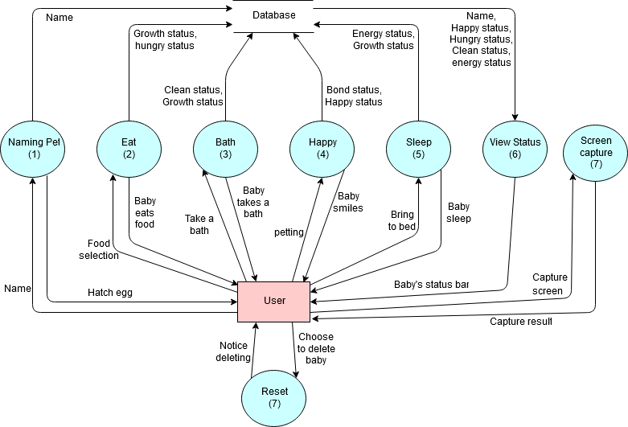

**The player can gain the status score which are**

|  |  |  |  |  |
| --- | --- | --- | --- | --- |
| **Score** | **Definition** | **Can gain upon which page/activity** | **How Score calculated** | **Shown up on the status page** |
| Hungry | If this score is high, it means that the baby is full. | Eat page / give food | Depends on food selection  Chicken +20  Hamburger +5  Cereal +30  Cake +10  Milk +30 | Yes |
| Happy | If this score is high, it means that the baby is happy. | Homepage/play with the baby | How long the player plays with the baby in second.  1 sec +5 happy score | Yes |
| Clean | If this score is high, it means that the baby is | Take a Bath page/turn on the shower | 1 time of turn on the shower +35 clean score | Yes |
| Energy | If this If this score is high, it means that the baby is clean. | Sleep page / open the page | 1 time call Sleep page = 40 energy score | Yes |
| Bond | This score shows how much the baby bond to the player, determine the adult form of a baby. | Homepage/play with the baby | How long the player plays with the baby in second.  1 sec +5 Bond score | No, because it needs to be hidden for the player to guess what their baby will look like after it becomes an adult. |
| Growth | It will be used to limit the game cycle and show the progress of baby grown. | All pages / all activities | Every one interaction +5 growth score*** | Yes |

After the growth score gets 100 which is the maximum, then the application will check the bond score. If the bond score is below 200, the baby will become a Godzilla; otherwise, it will become cute Tyrannosaurus.

***Growth score will not be increased in the case when the other score is full; for instance, if the hungry score is full, then the player continues to give the baby a food, the growth score will not be increasing.

All status score will be deducted when the player closes the application. For this project, we deducted it by the second for testing and demo, which can be adjusted later.

**The system architecture**

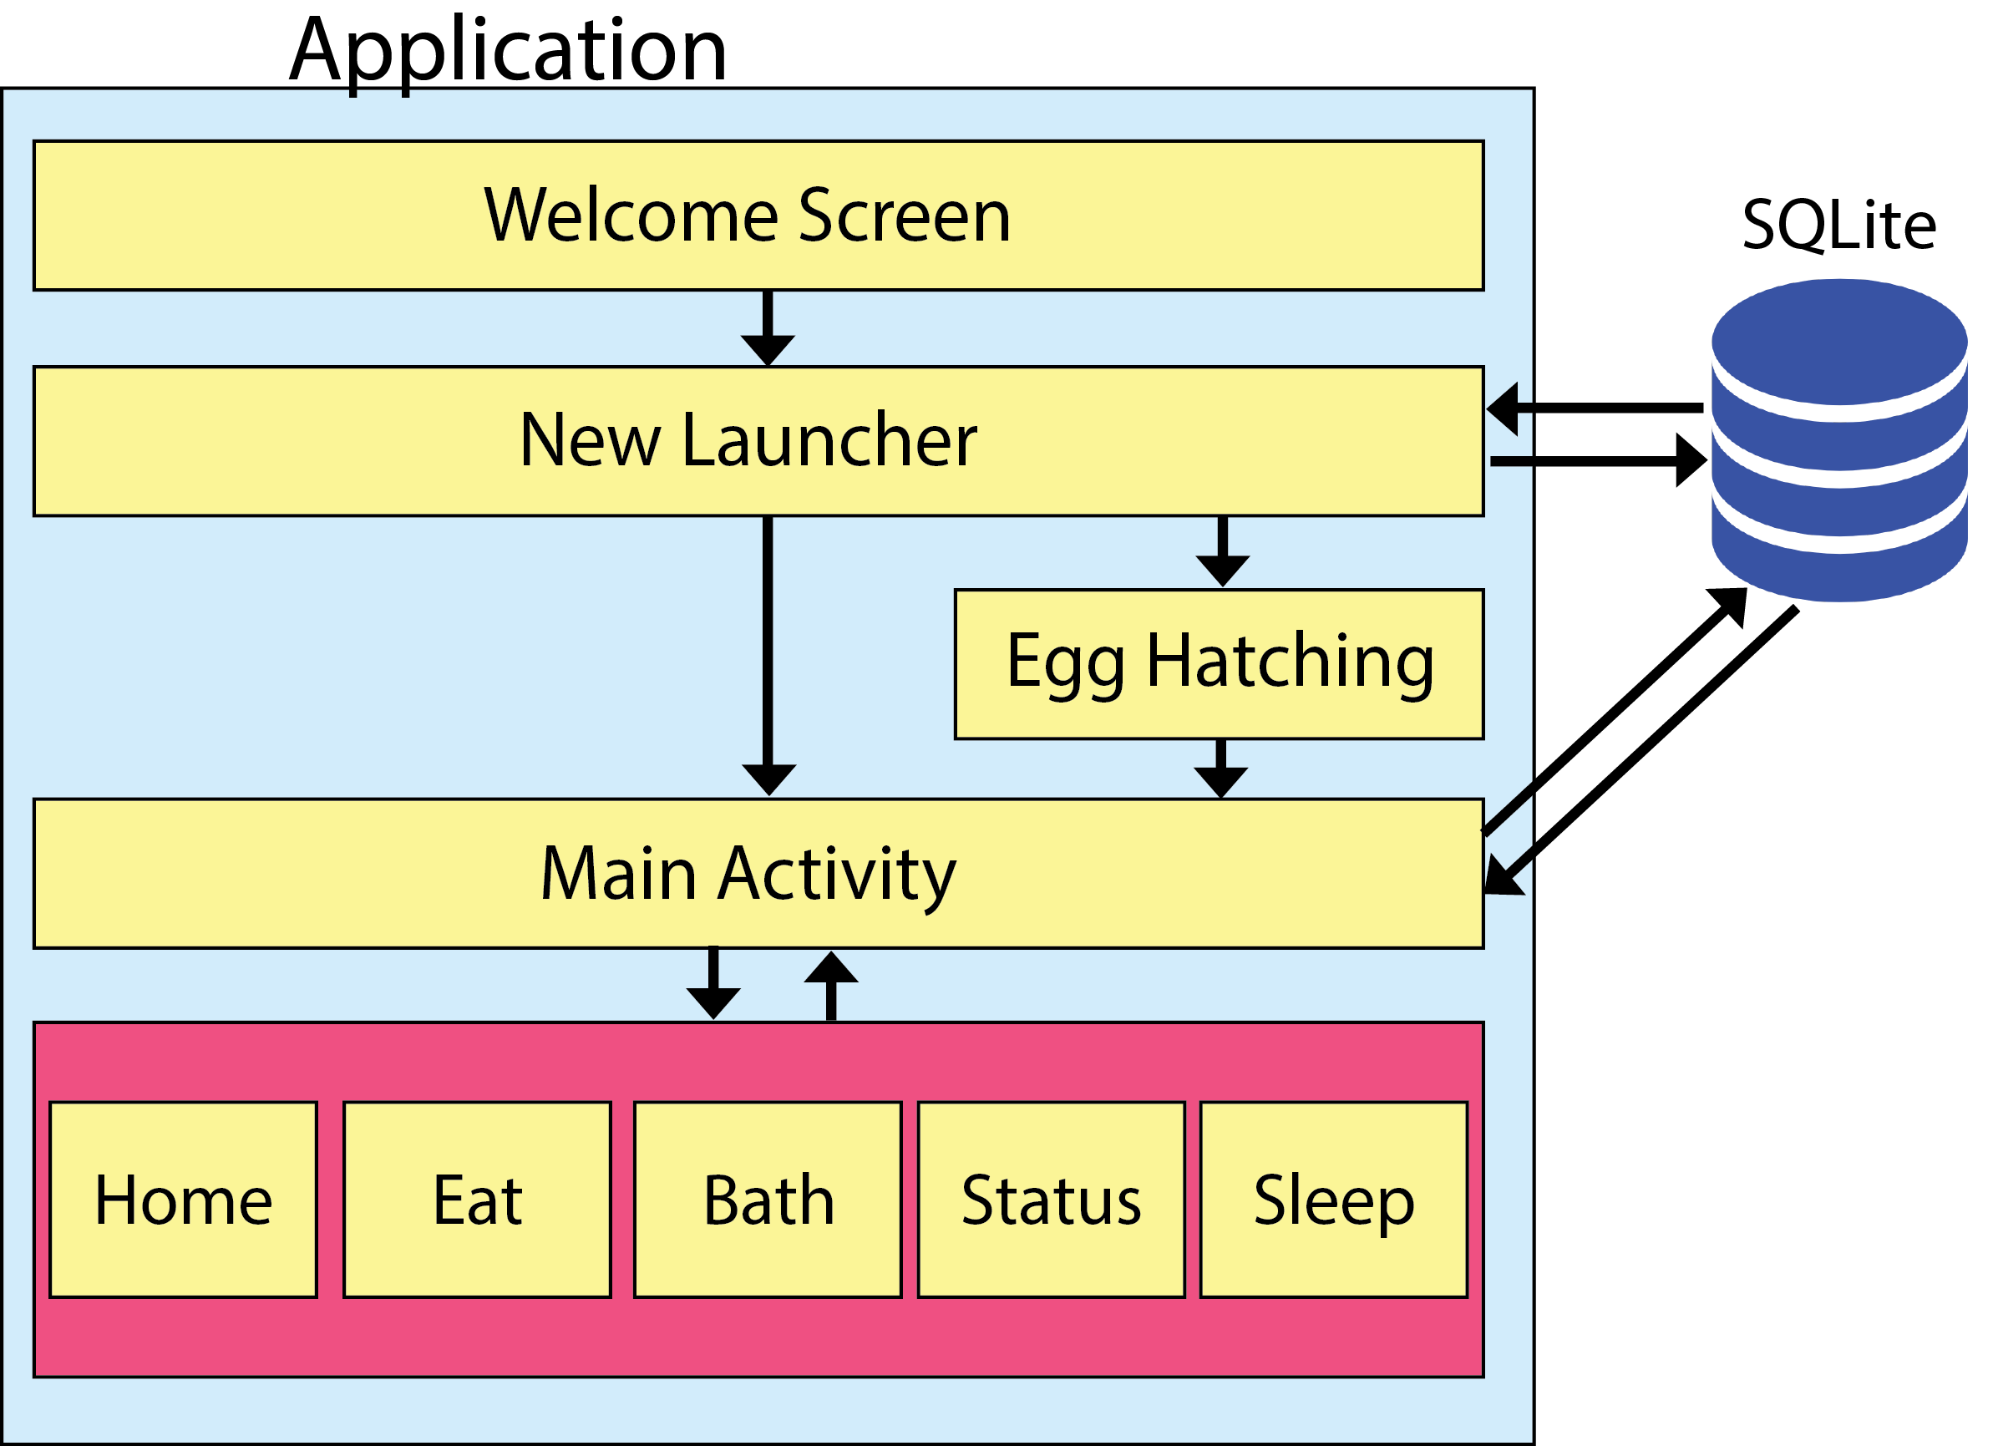

**Screenshots of at least one activity of your application.**

The image below is the welcome screen that always appears when the application starts.

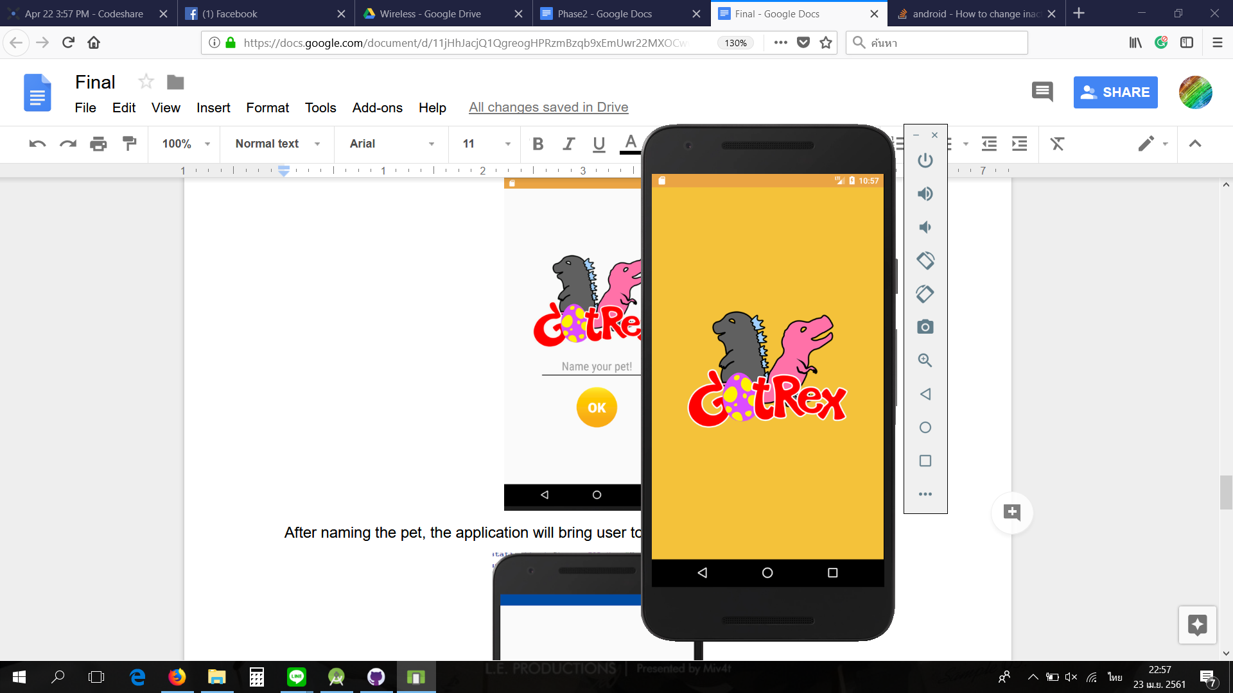

The *New Launcher activity* that is used for the player to input the name of the baby.

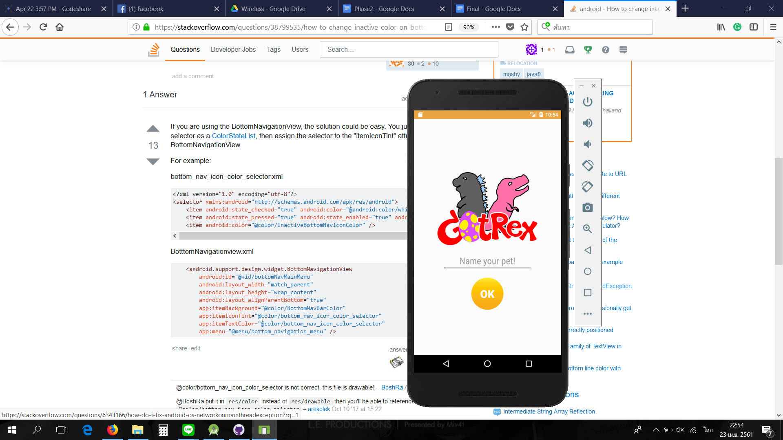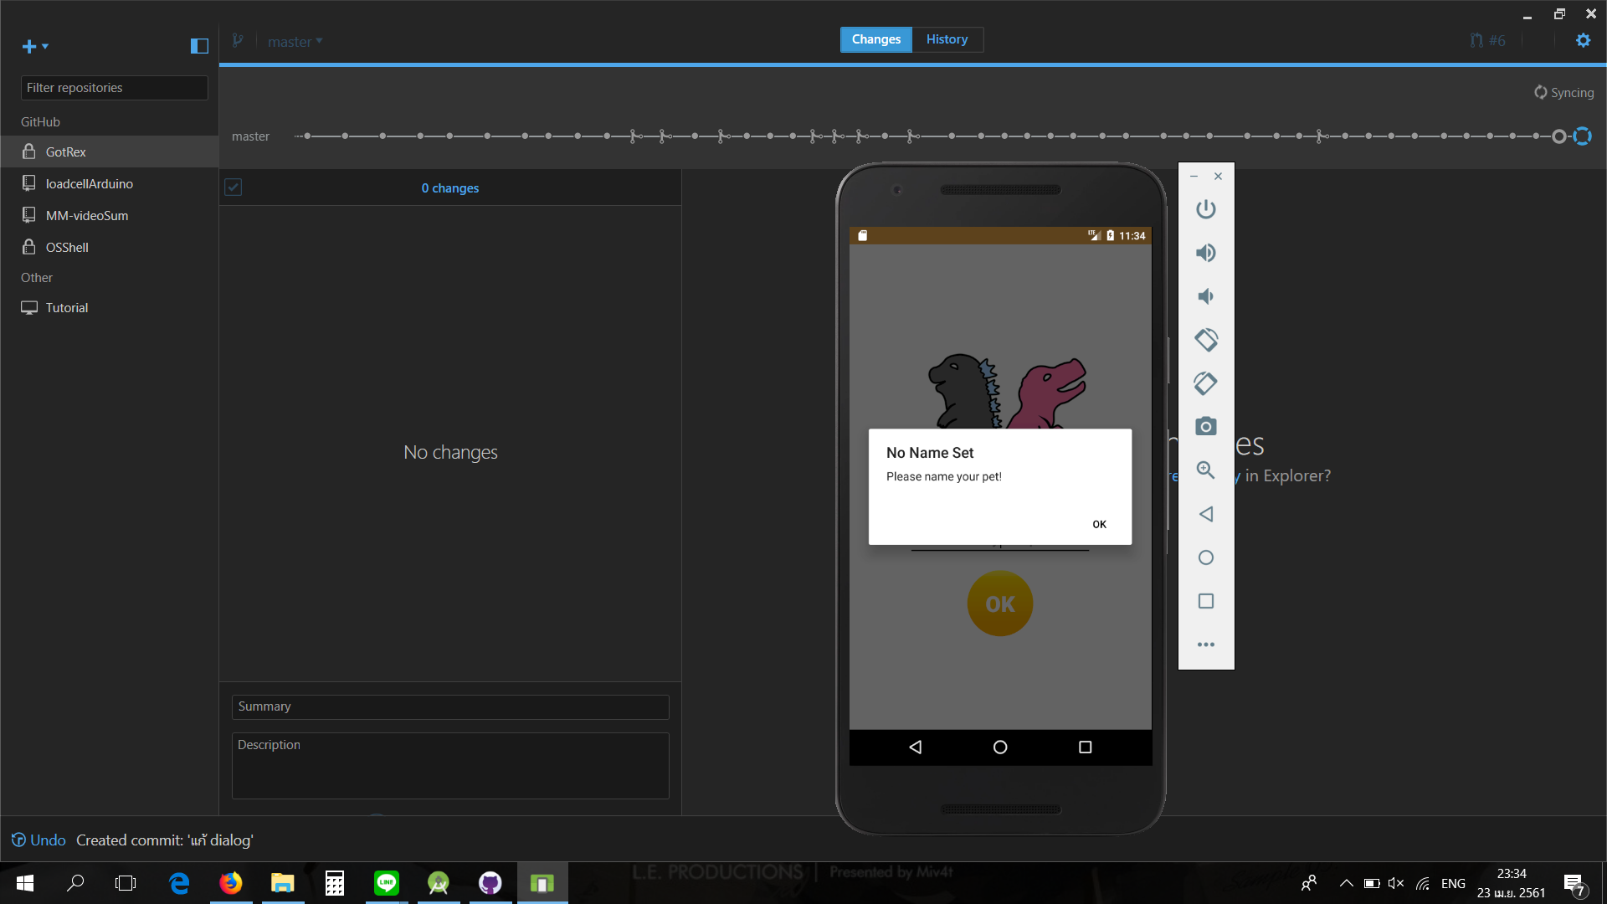

After naming the pet, the application will bring the player to hatching egg page. Waiting for this page a while, the application will navigate the player into the *Main Activity*.

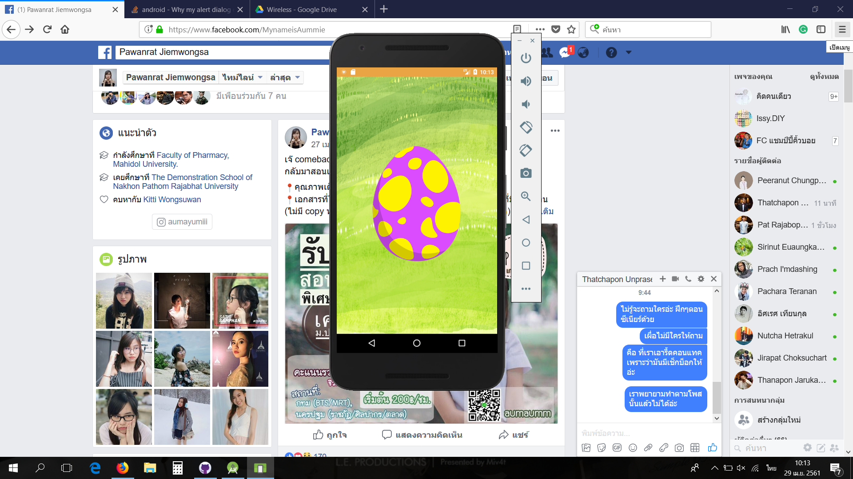

*Main Activity* page will call fragments by using bottom navigation. Below here is the home page or home fragment, the player can petting on it to increase the baby’s happy score.

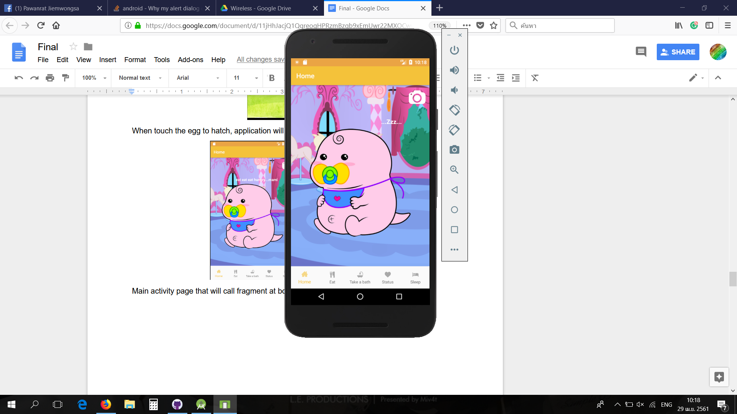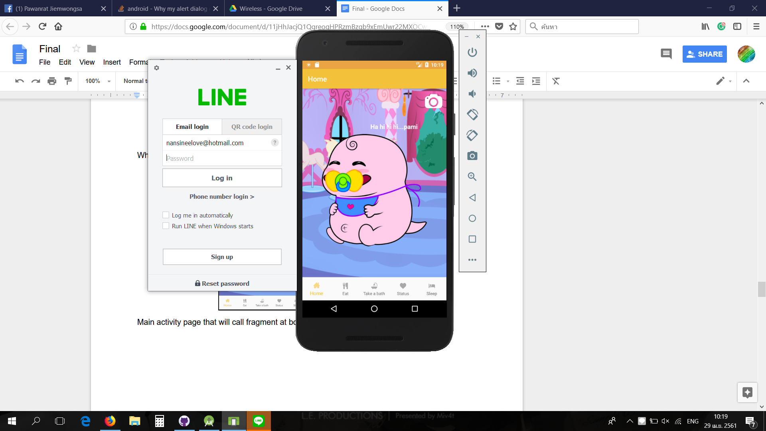

*Eat Fragment* will let the player drag the food to baby Gotrex to full their baby.

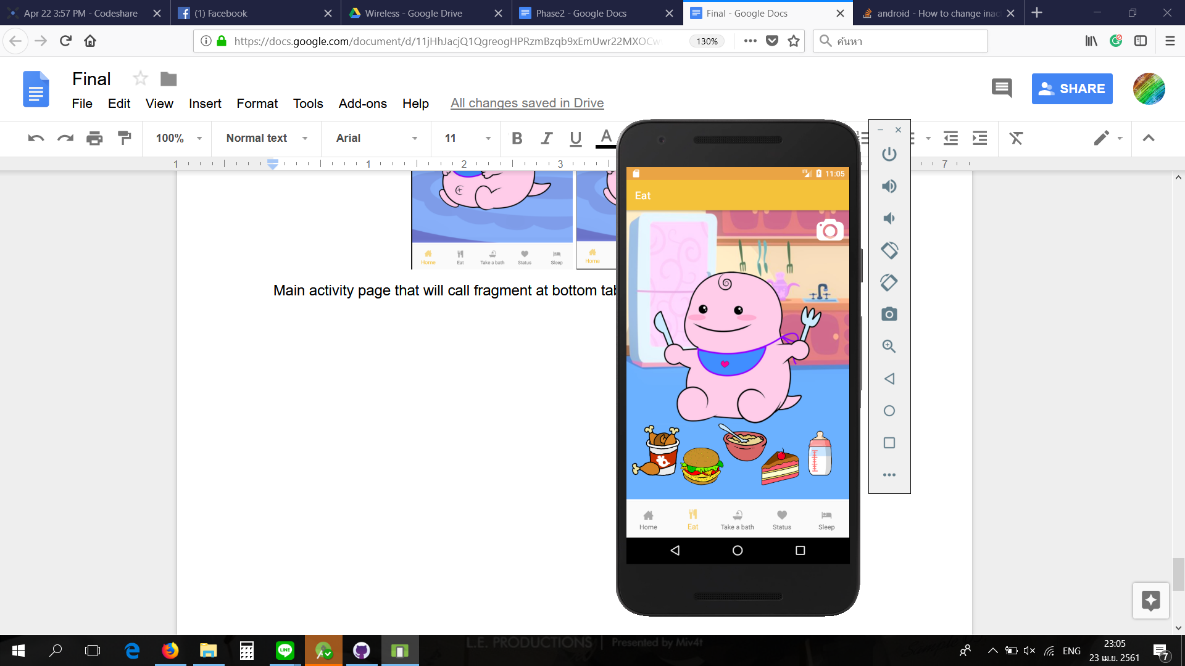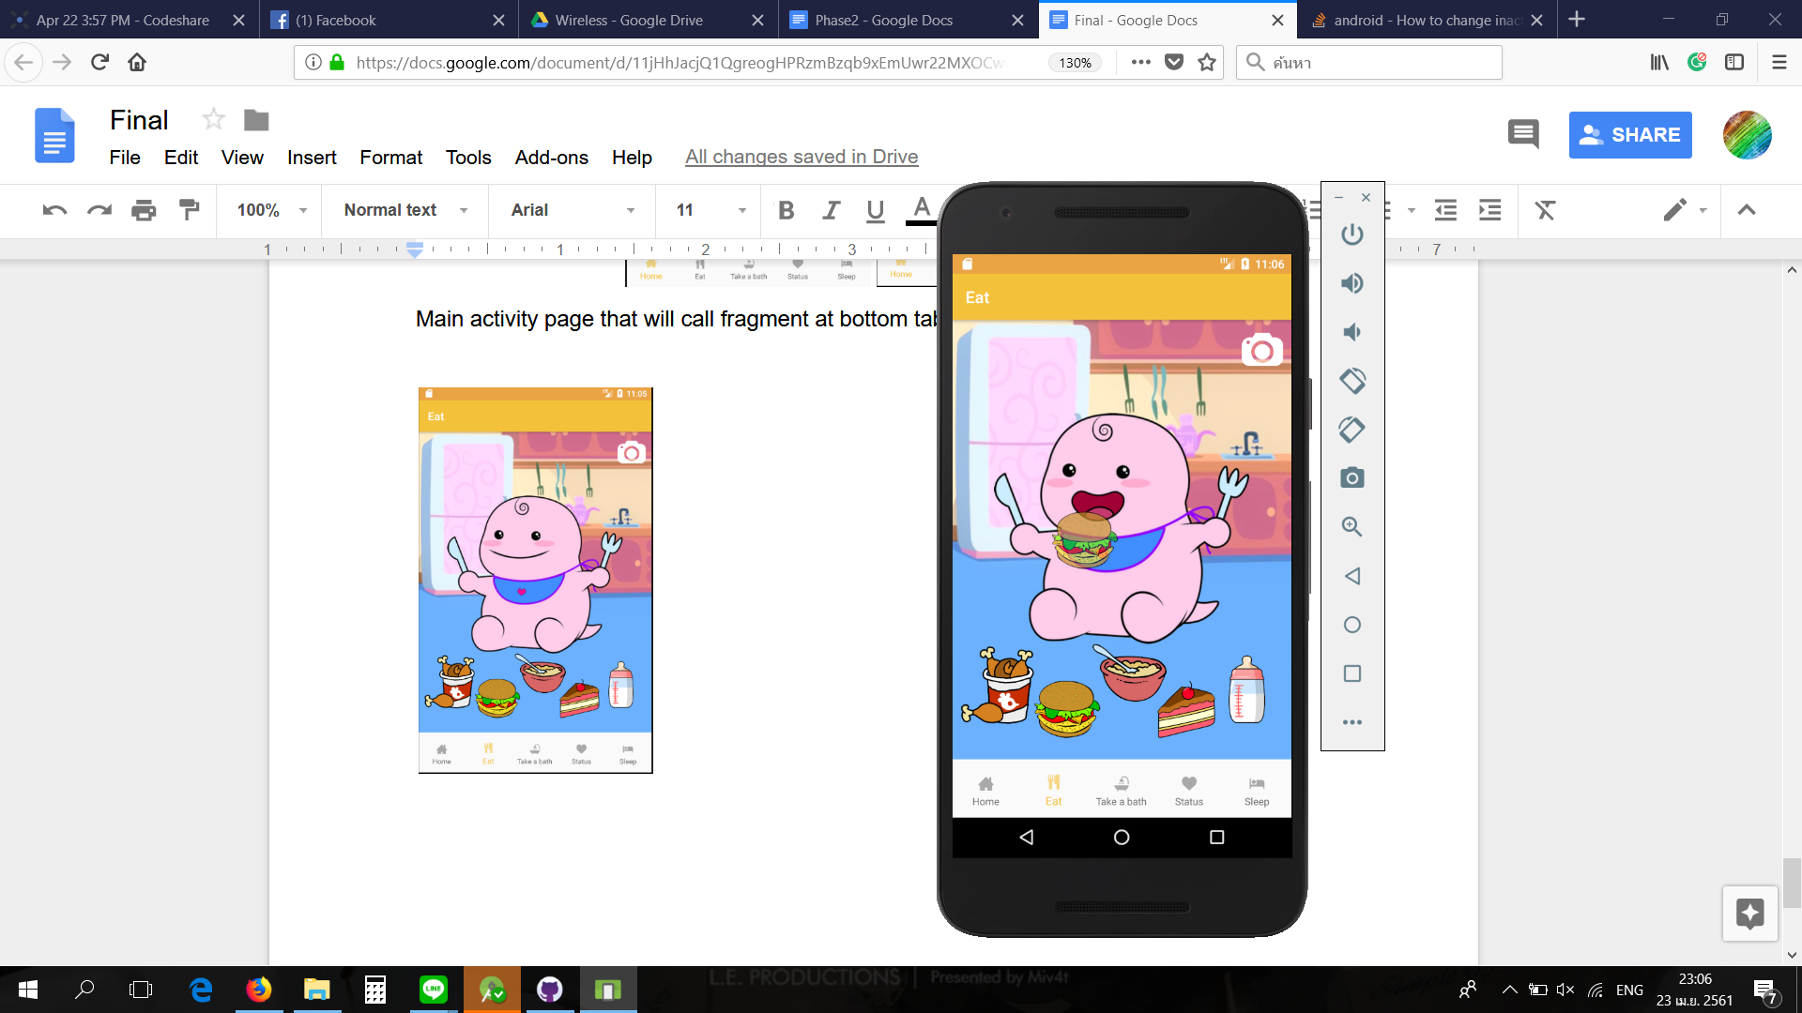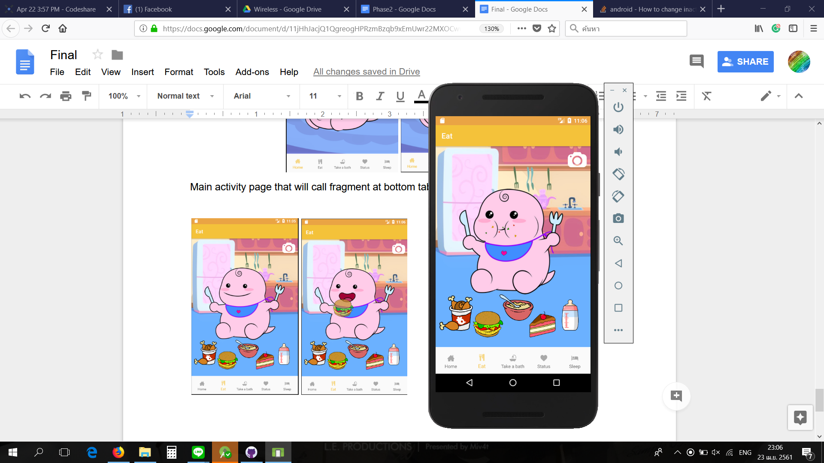

*Bath Fragment* will let the player bath their baby to increase their baby cleanness.

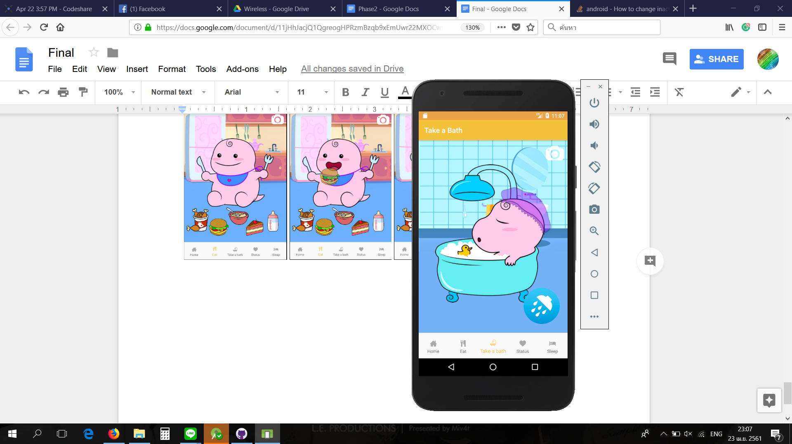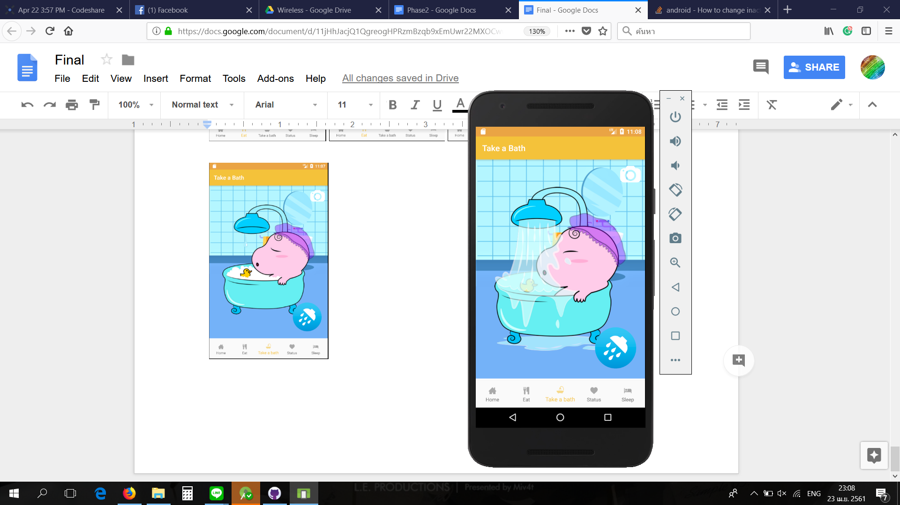

*Sleep Fragment* will take their baby Gotrex to bed to increase their baby energy.

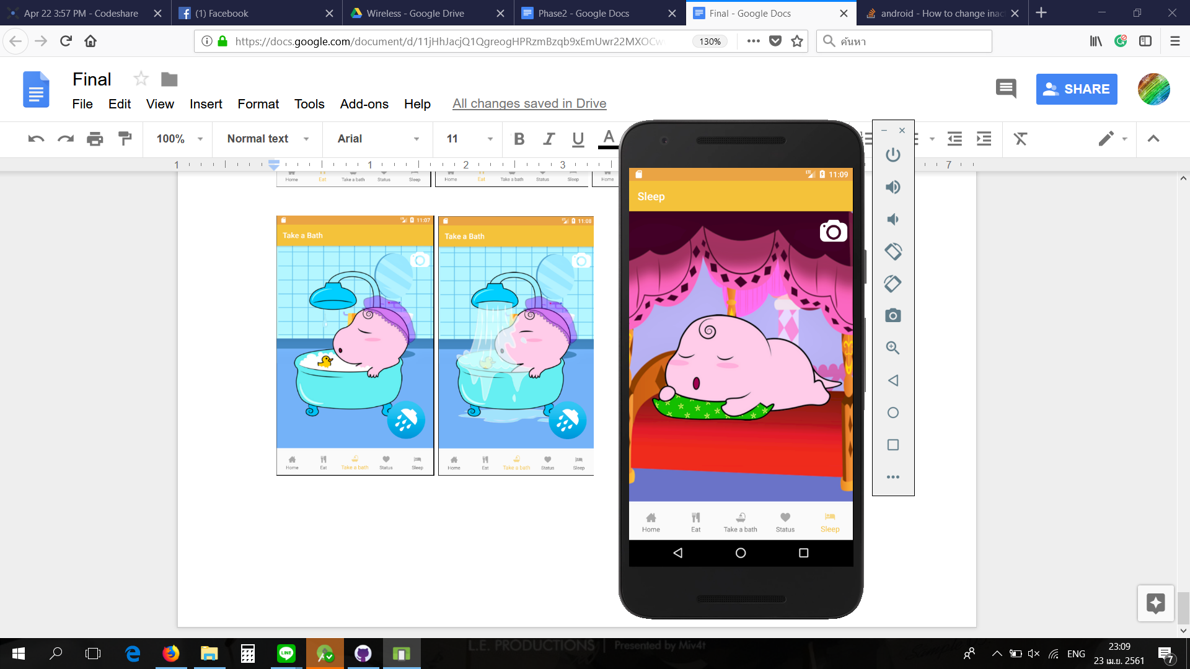

*Status Fragment* shows their baby status bar and growth progress. If the player closes the application the score will be deducted.

There is a delete button which a player can use it to delete their current baby to start a new one.

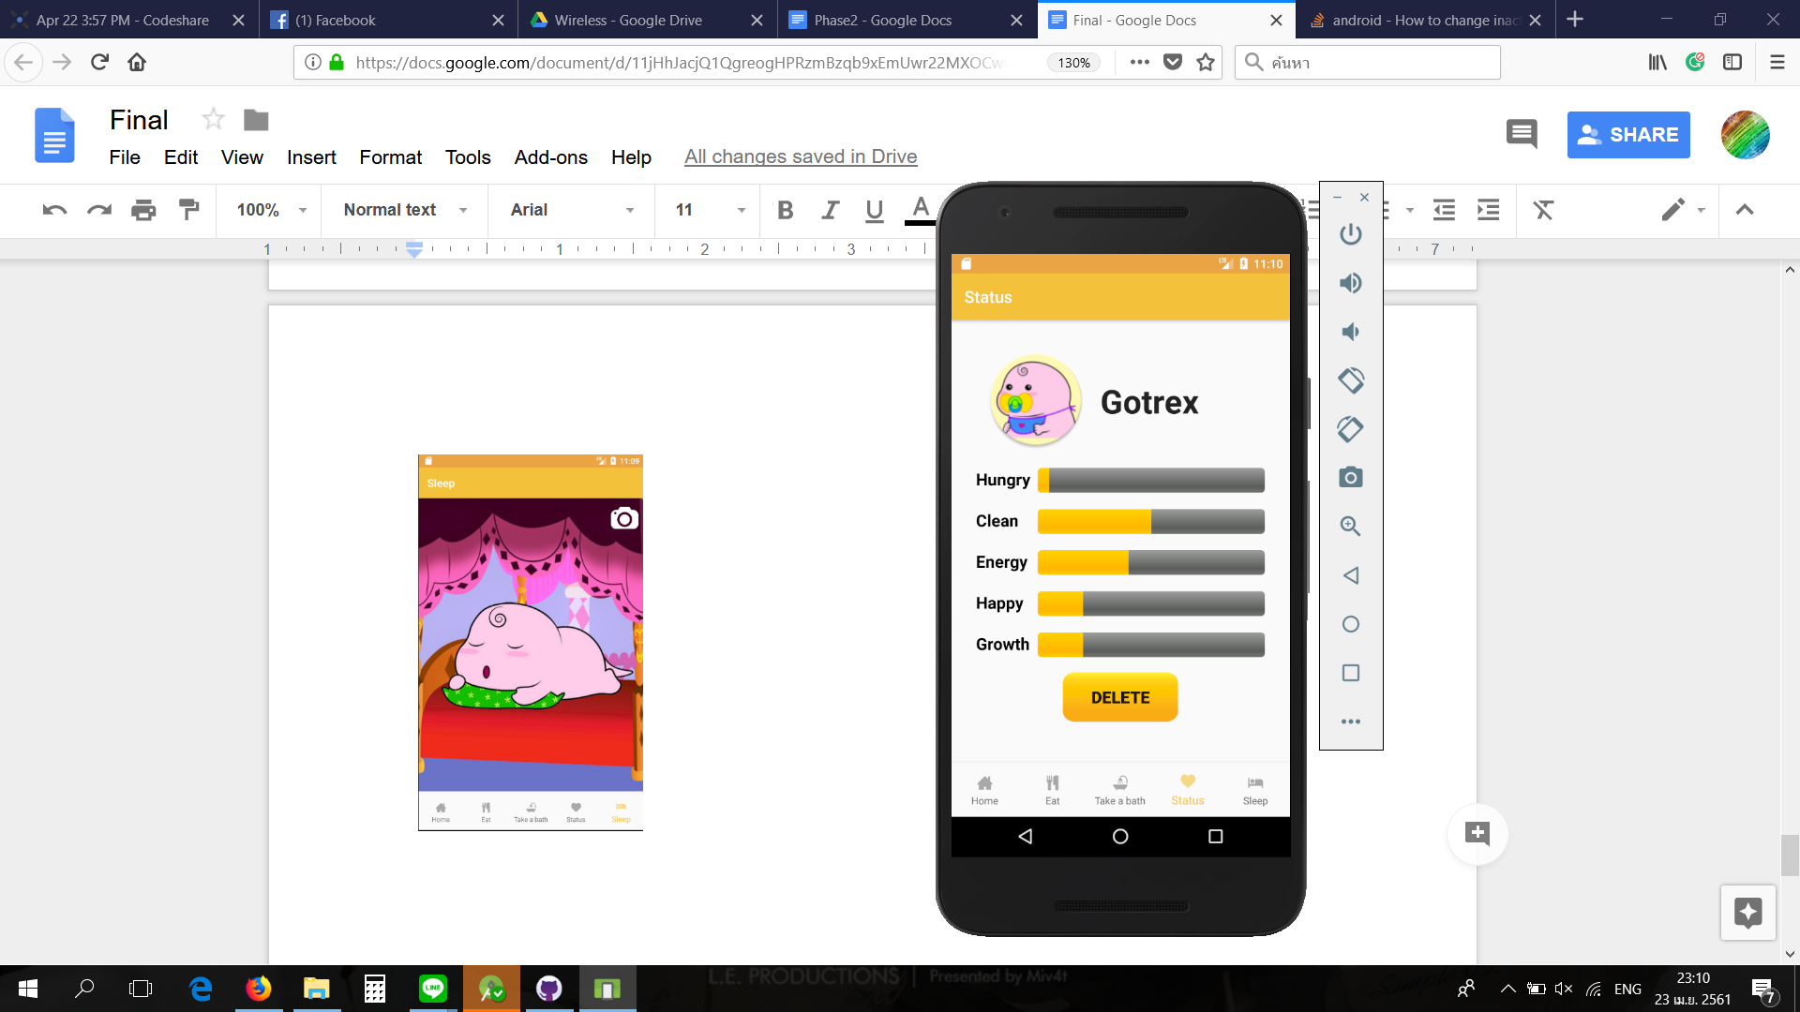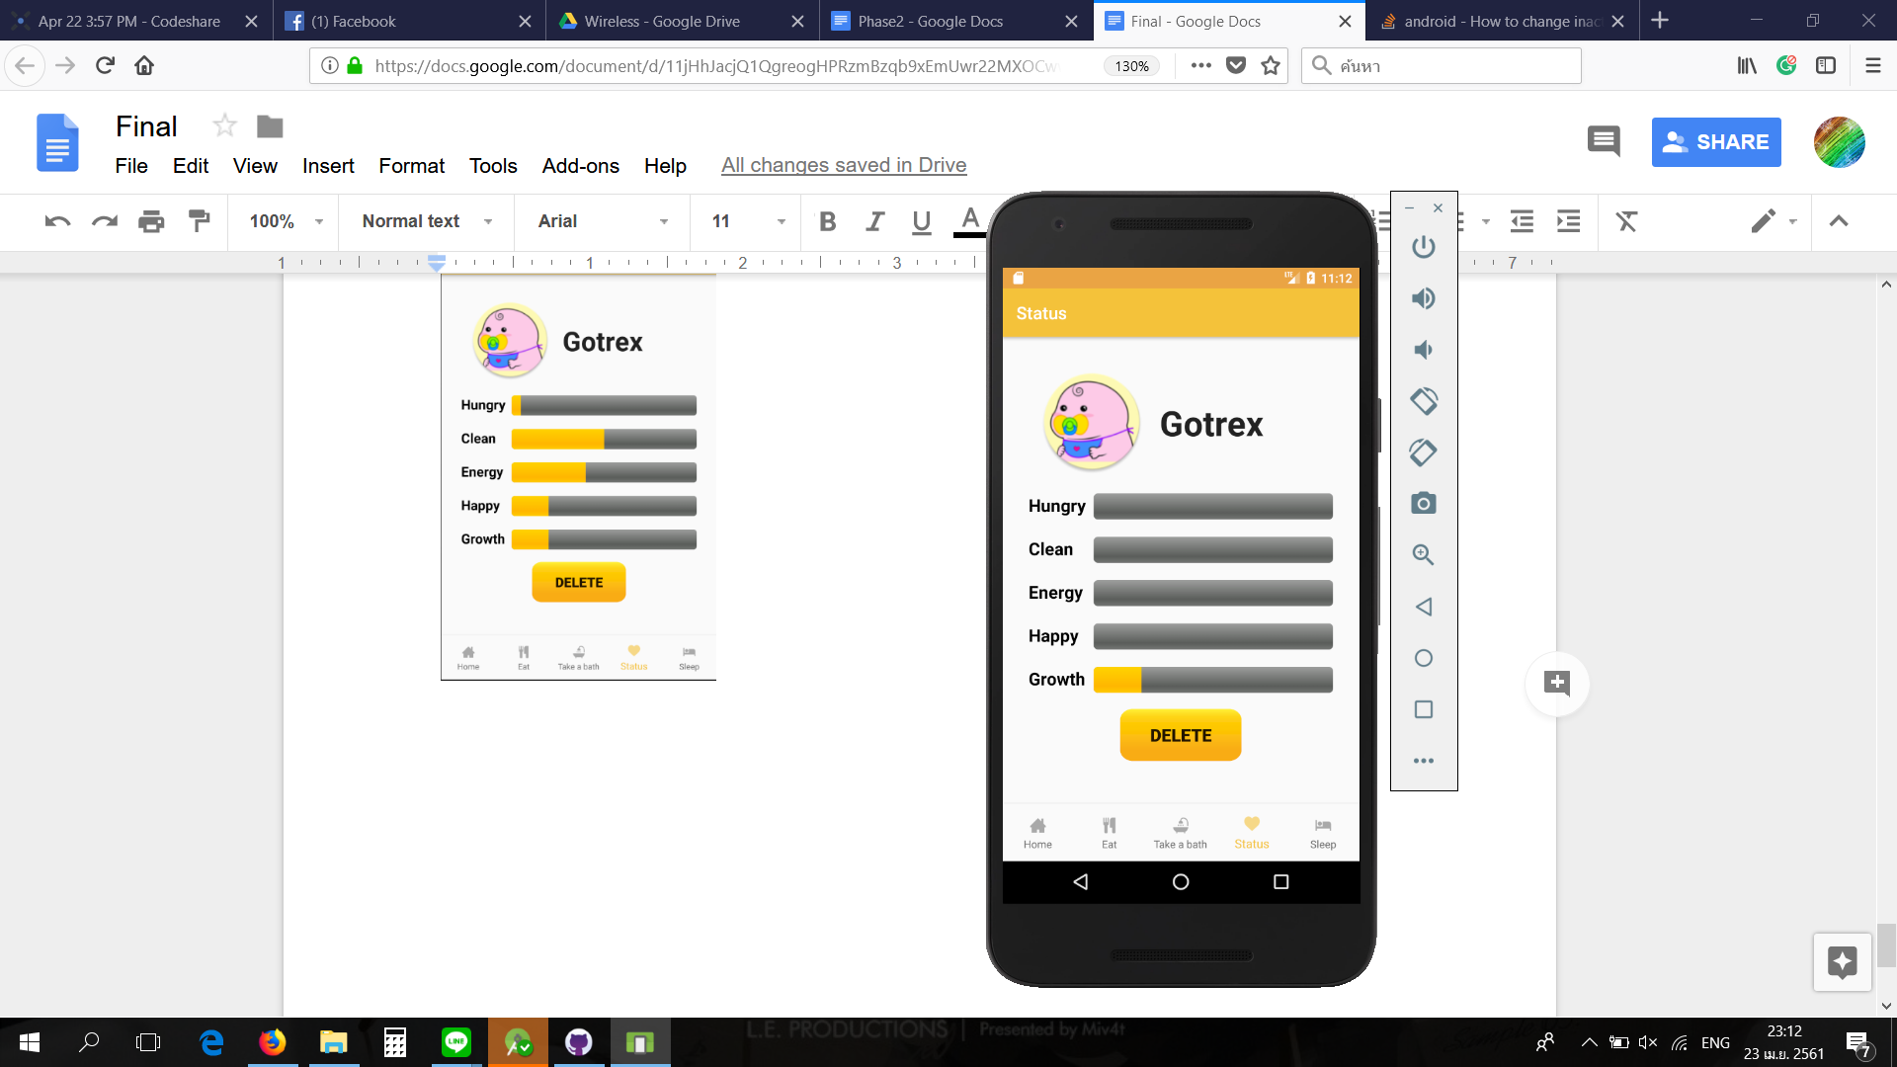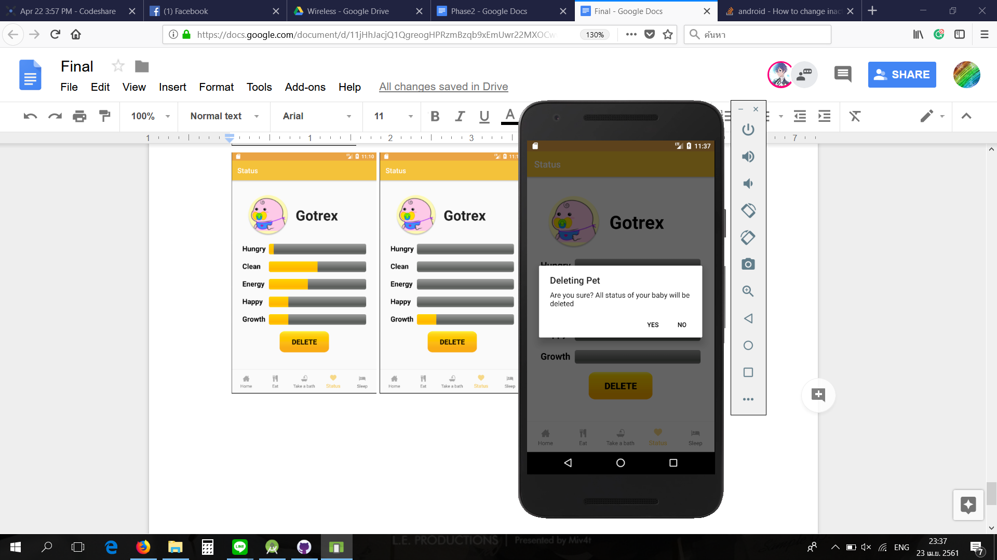

When growth status reaches the max value, baby Gotrex will evolution into Godzilla or T-rex based on player care.

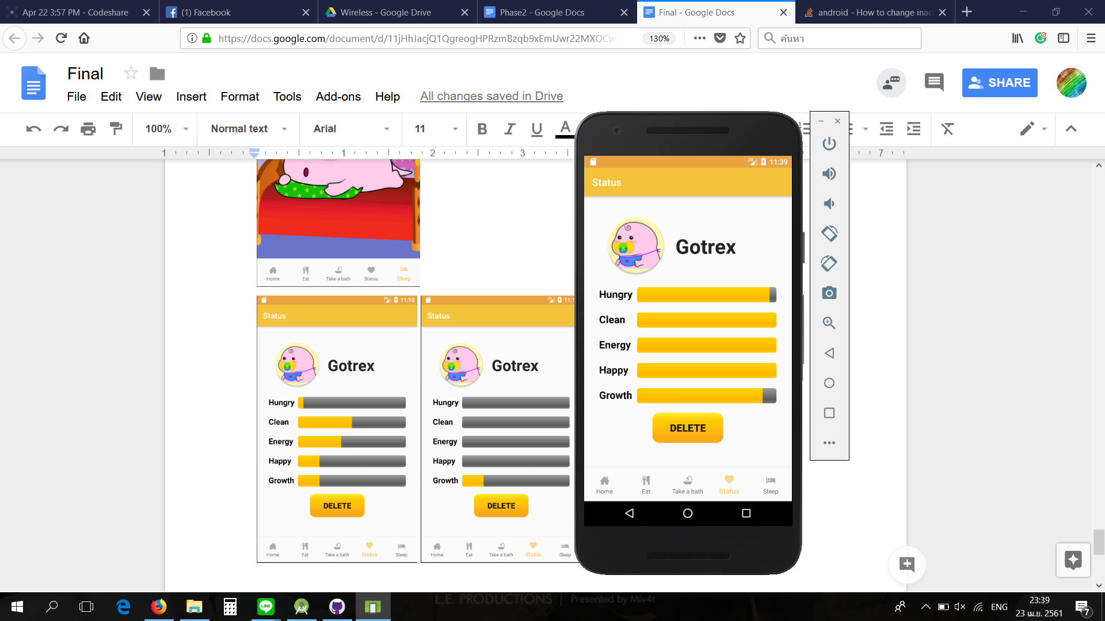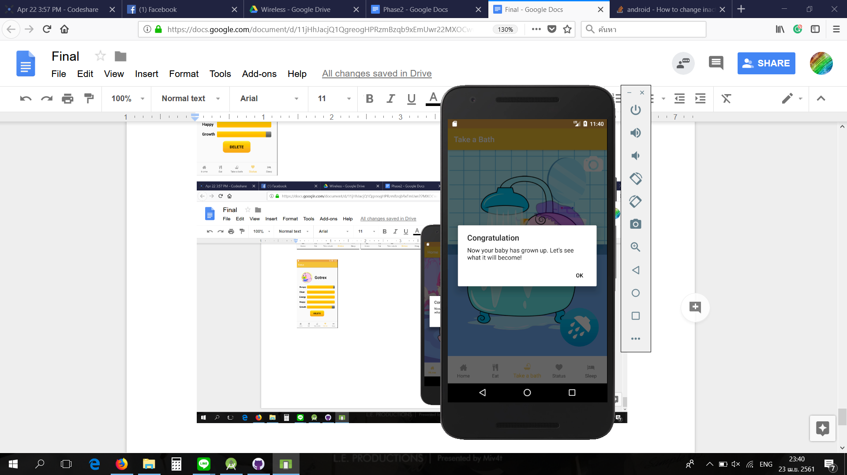

*Growth Activity* will show the Gotrex evolution. A player can click play again to name their new baby Gotrex.

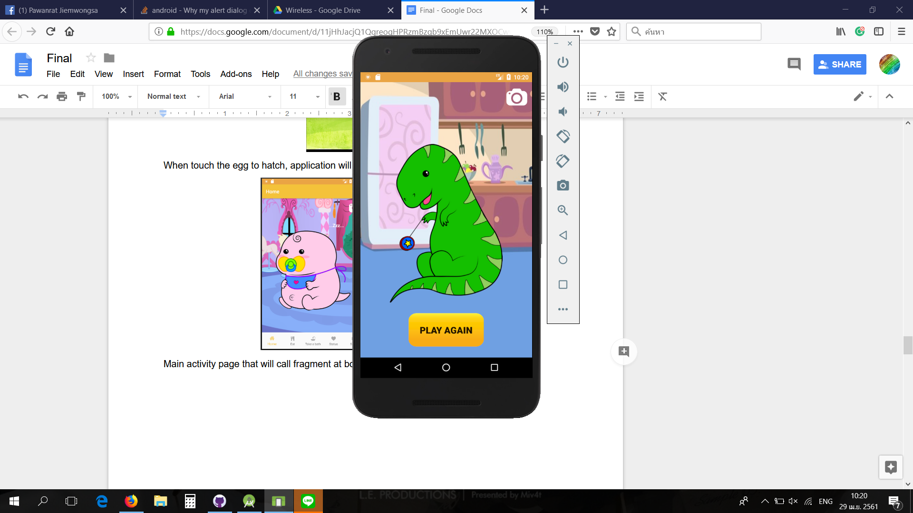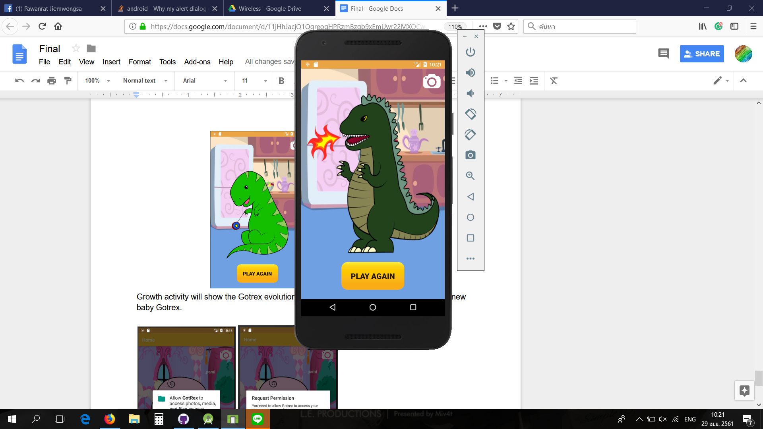

The player can tap on a camera button on the up-right corner to capture the screen, then the photo will be saved in the device. However, the application will request permission to access the storage before saving. If the player denies, it will show the explanation instead.

